**Name:Vedashree Anand Ekbote**

**PRN:22010423**

**Roll No.333018**

**TY_IT_C_C1**

**Assignment No. 1**

**Study Linux Commands**

1. mkdir:

It stands for “make directory”, allows user to create directories in order specified.

1. ls:

It is used for listing the contents inside the directories.

Above 2 commands implemented:

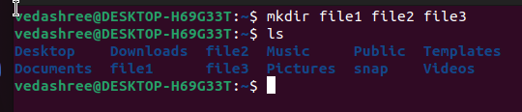

1. cd:

It is known as change directory command. It is used to change current working directory and move inside the desired directories.

1. pwd:

It is known as “Present working directory”. This command writes the full path name of your current directory.

Above 2 commands implemented:

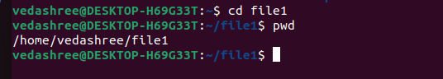

1. touch:

Used to create single file at a time.

1. echo:

Used to display line of text or string that are passed as an argument.

Above 2 commands implemented:







7.mv:

mv stands for move. mv is used to move one or more files or directories from one place to another in a file system like UNIX.

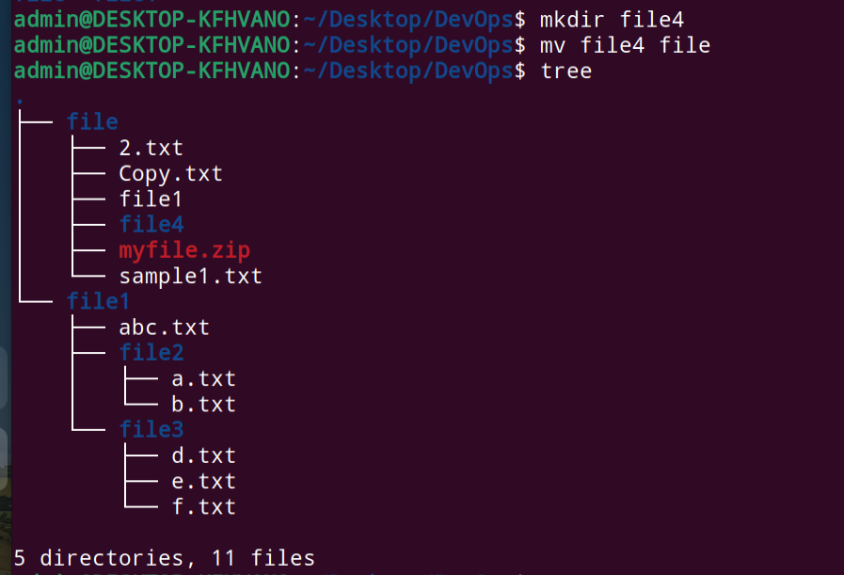

8.cp:

cp stands for copy. This command is used to copy files or groups of files or directory.



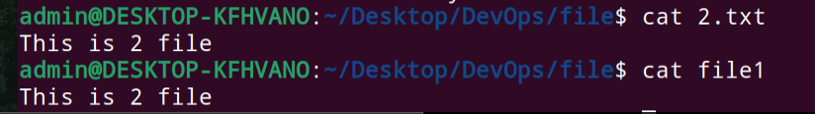

9.rm:

The rm command removes the entries for a specified file, group of files, or certain select files from a list within a directory

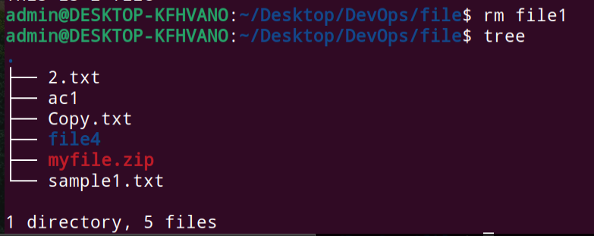

ln:

ln command is used to create hard links and soft links for files in Linux.

1.Symbolic links are most useful for avoiding complicated paths.

2.Symbolic links make it easy to make some set of files appear to exist in multiple locations without having to make separate copies.

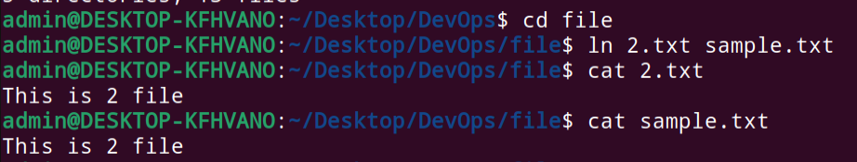

cat:

It reads data from the file and gives their content as output. It helps us to create, view, and concatenate files.



less:

The less command is a Linux terminal pager that shows a file's contents one screen at a time.

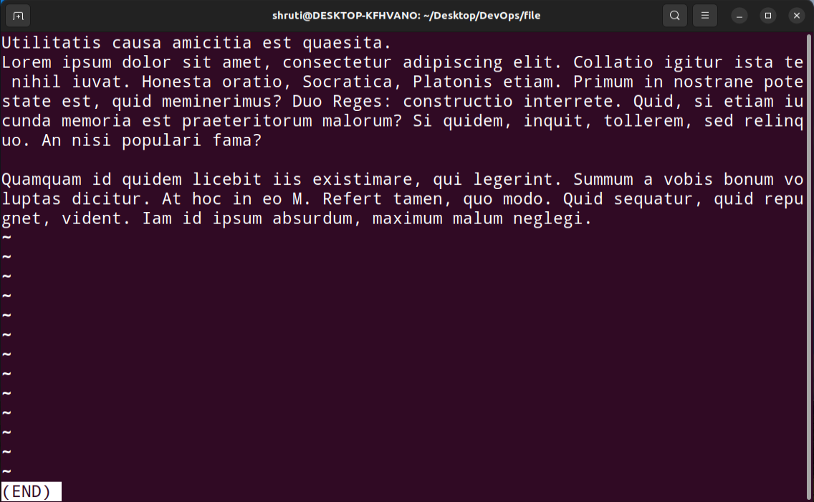

man;

used to display the user manual of any command that we can run on the terminal. It provides a detailed view of the command which includes NAME, SYNOPSIS, DESCRIPTION, OPTIONS, EXIT STATUS, RETURN VALUES, ERRORS, FILES, VERSIONS, EXAMPLES, AUTHORS and SEE ALSO.

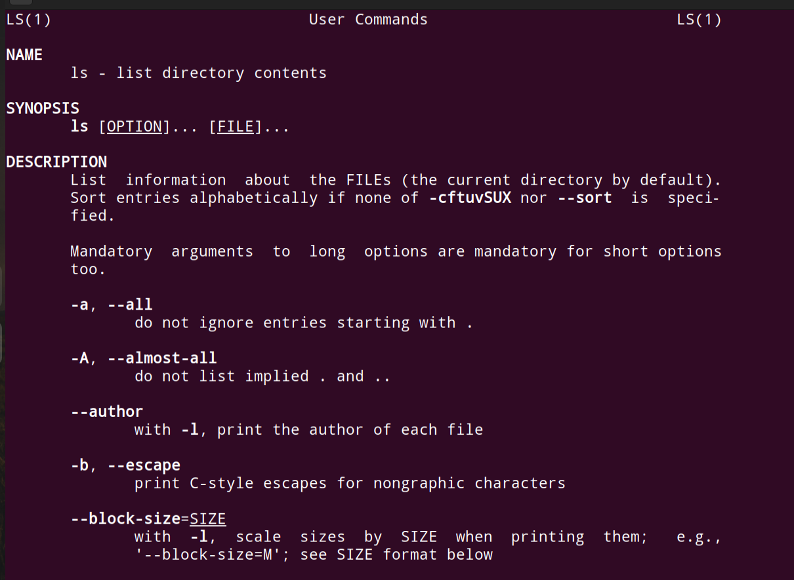

uname:

The uname command writes to standard output the name of the operating system that you are using.



whoami:

The whoami command allows Linux users to see the currently logged-in user. The output displays the username of the effective user in the current shell. Additionally, whoami is useful in bash scripting to show who is running the script.

tar:

The Linux 'tar' stands for tape archive, is used to create Archive and extract the Archive files.Command to extract and compress files in Linux.

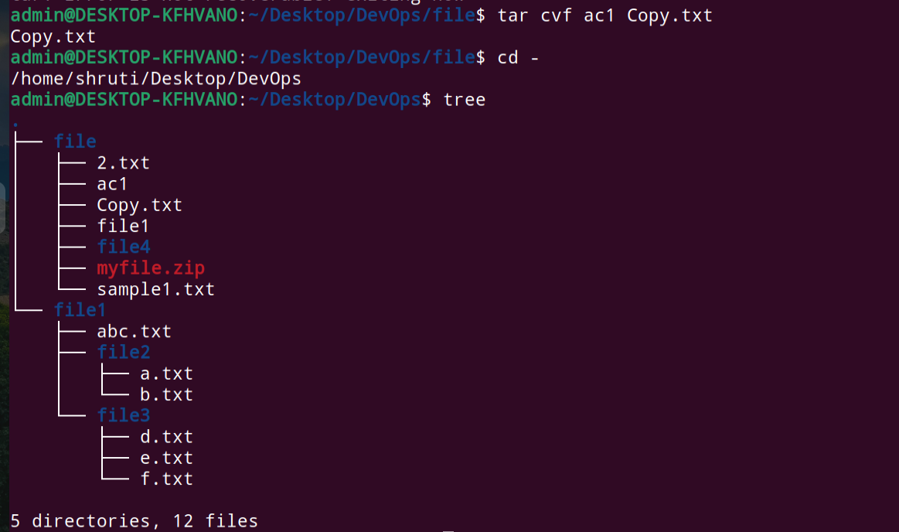

grep:

Search for a string within an output.



head:

The Linux head command prints the first lines of one or more files (or piped data) to standard output. By default, it shows the first 10 lines. However, head provides several arguments you can use to modify the output.

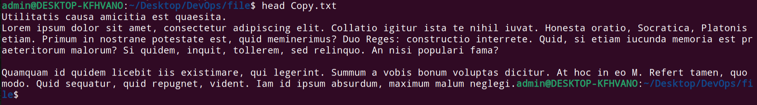

tail:

It is the complement of head command.The tail command, as the name implies, prints the last N number of data of the given input.

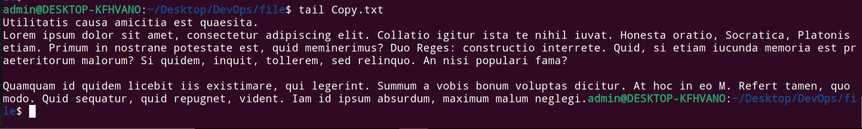

diff:

diff is a command-line utility that allows you to compare two files line by line.

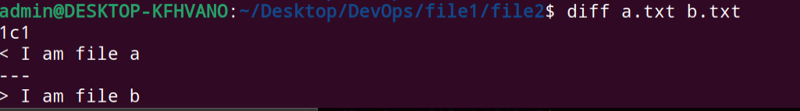

cmp:

The cmp command compares files designated by the File1 and File2 parameters and writes the results to standard output.



comm:

comm compare two sorted files line by line and write to standard output; the lines that are common and the lines that are unique.



sort:

SORT command is used to sort a file, arranging the records in a particular order.

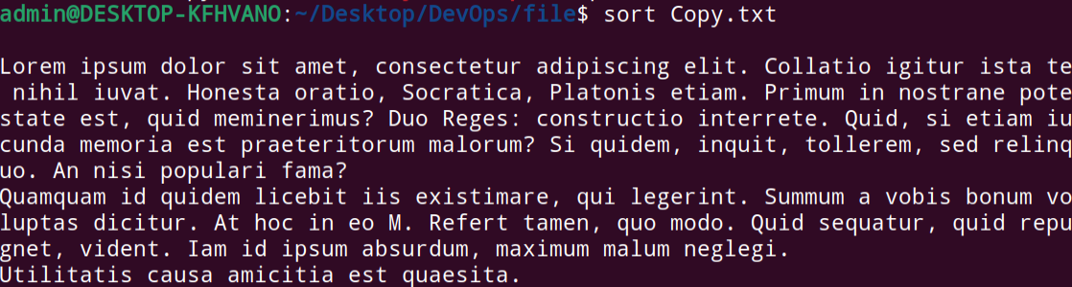

export:

Export is a built-in command of the Bash shell. It is used to mark variables and functions to be passed to child processes. Basically, a variable will be included in child process environments without affecting other environments.

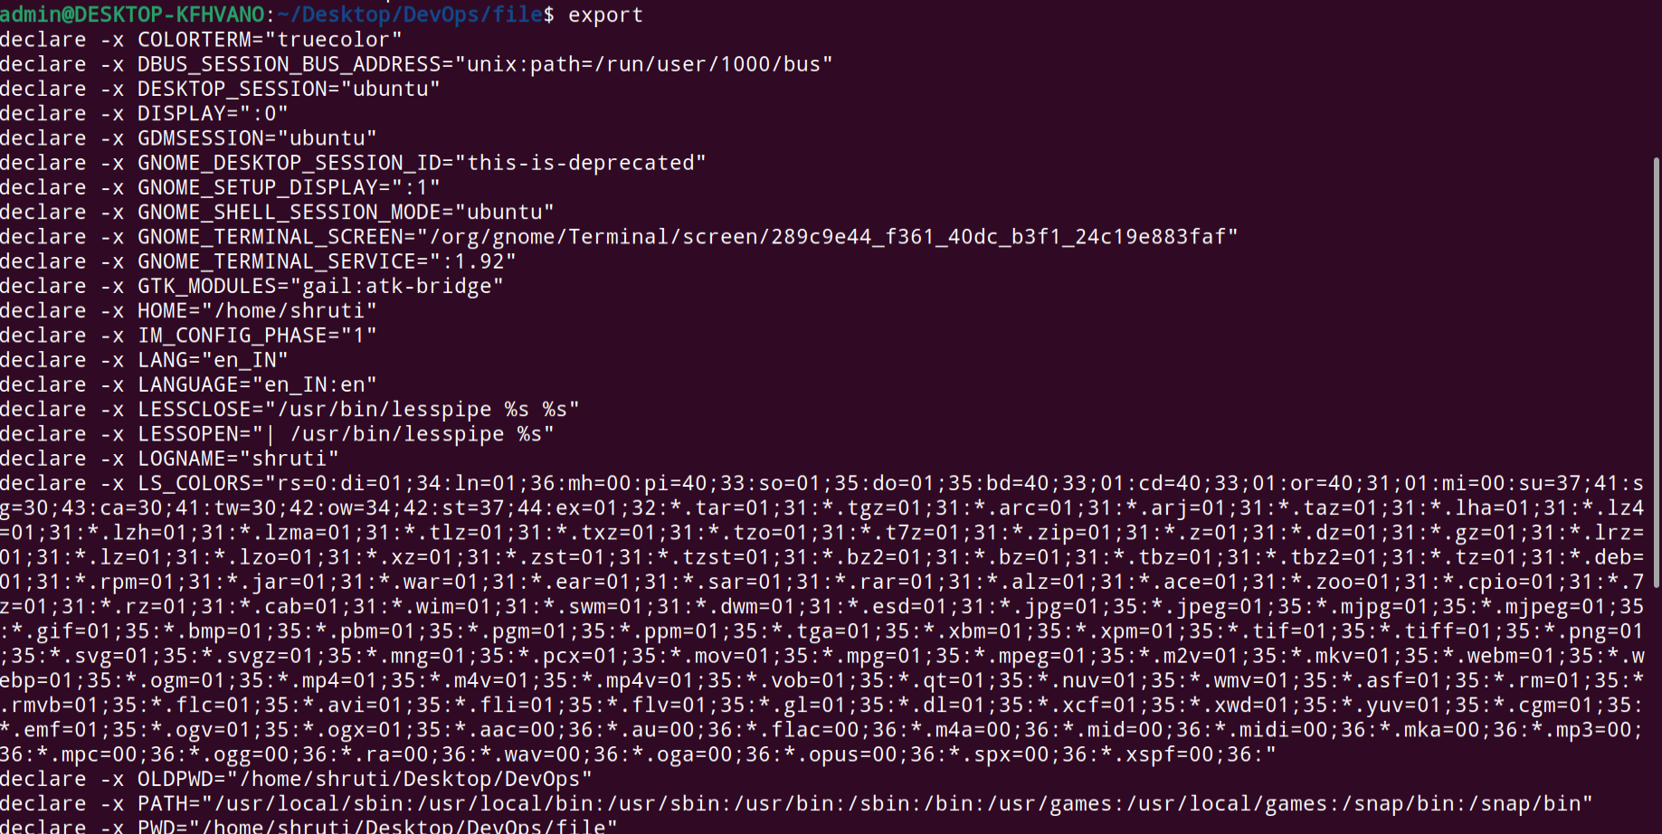

zip:

This option supports us to zip every file that exists inside the specified directory.

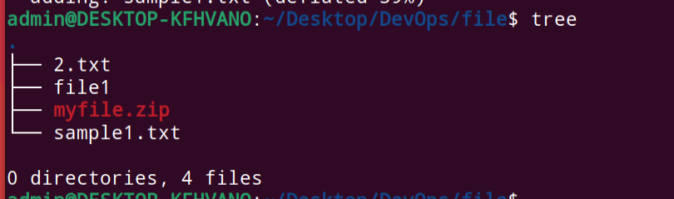

unzip:

It unzips files in Linux.

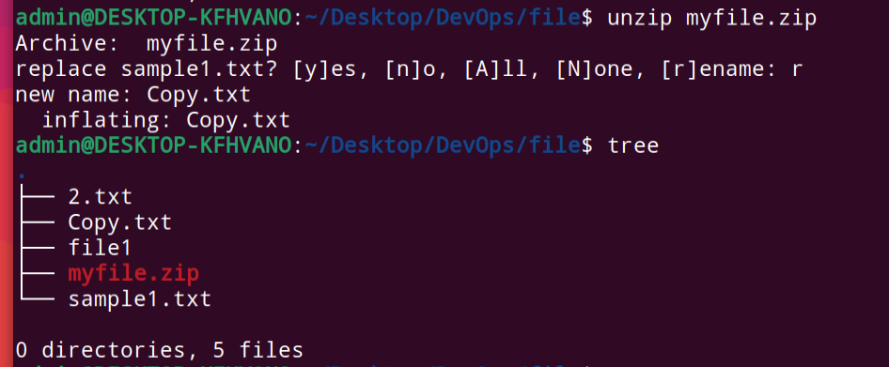

ssh:

ssh stands for “Secure Shell”. It is a protocol used to securely connect to a remote server/system.

service:

The service command starts, stops and restarts a daemon or services by calling the script.

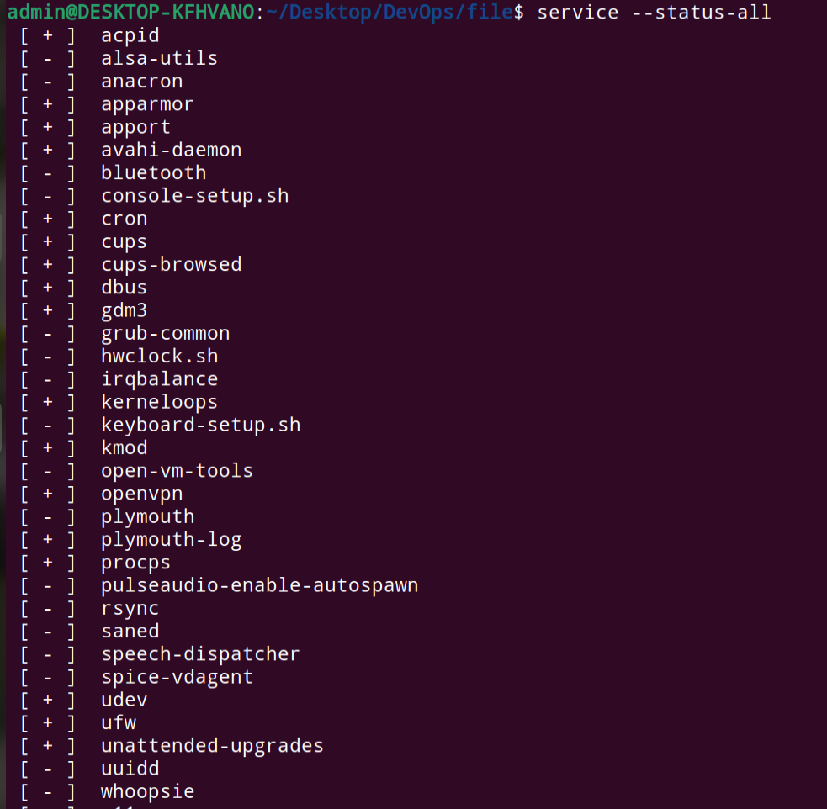

Ps:

ps command is used to list the currently running processes and their PIDs along with some other information depending on different options.

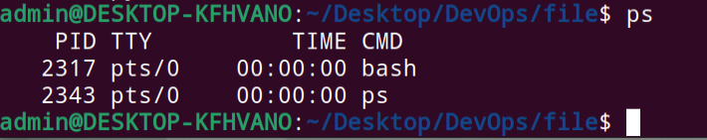

kill and killall:

killall is a tool for terminating running processes on your system based on name. In contrast, kill terminates processes based on Process ID number (PID). kill and killall can also send specific system signals to processes.

df:

The df command displays the amount of disk space available on the filesystem with each file name's argument.

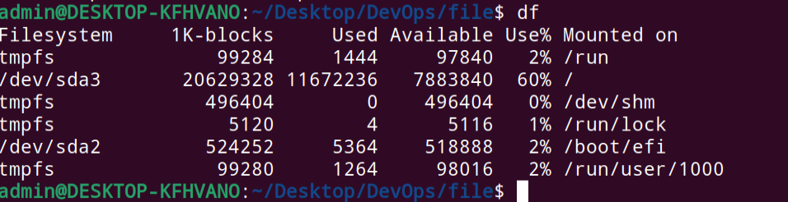

mount:

The mount command allows users to mount, i.e., attach additional child file systems to a particular mount point on the currently accessible file system.

chmod:

In Unix-like operating systems, the chmod command is used to change the access mode of a file. The name is an abbreviation of change mode.



chown:

The chown command changes the owner of the file or directory specified by the File or Directory parameter to the user specified by the Owner parameter.

ifconfig:

The ifconfig function displays the current configuration for a network interface when no optional parameters are supplied.

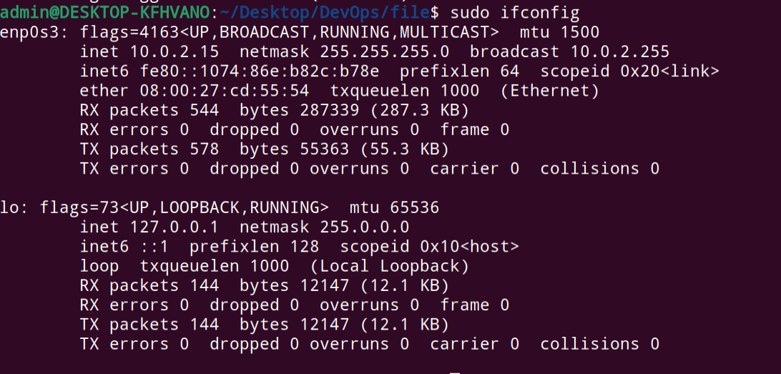

traceroute:

This command in Linux prints the route that a packet takes to reach the host. traceroute command in Linux prints the route that a packet takes to reach the host.

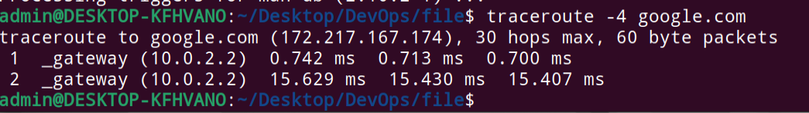

wget:

Command wget stands for web get. The wget is a free non-interactive file downloader command. Non-interactive means it can work in background when user is not logged in.

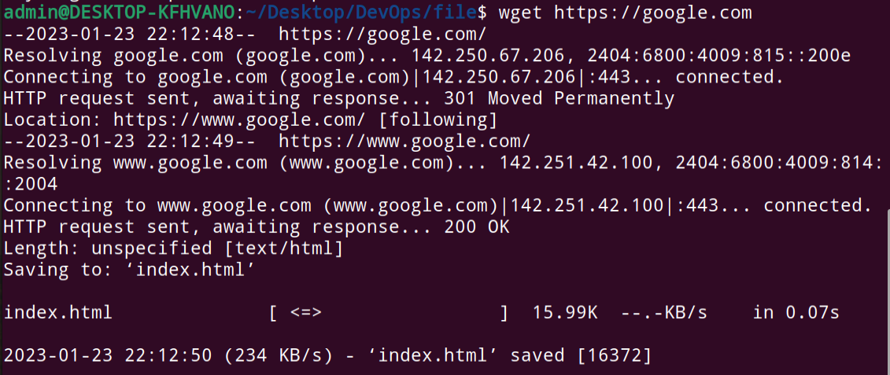

ufw:

UFW, or uncomplicated firewall, is a frontend for managing firewall rules in Arch Linux, Debian, or Ubuntu.

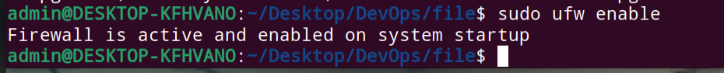

iptables

iptables is a command line interface used to set up and maintain tables for the Netfilter firewall for IPv4, included in the Linux kernel.

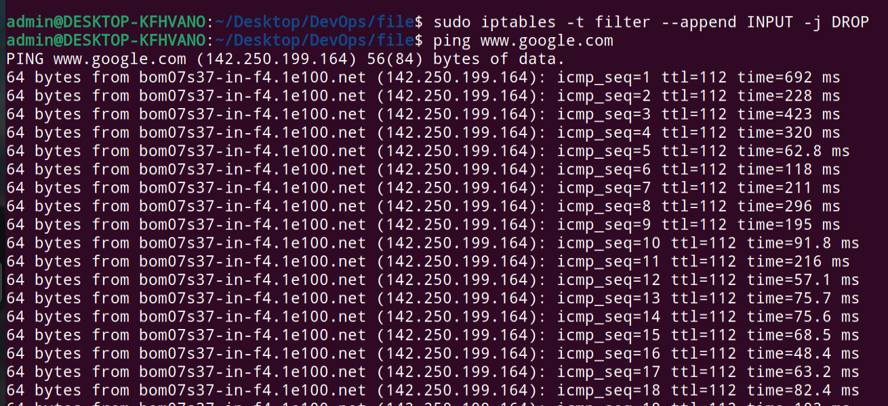

apt:

apt, is a collection of tools used to install, update, remove, and otherwise manage software packages on Debian and its derivative operating systems, including Ubuntu and Linux Mint.

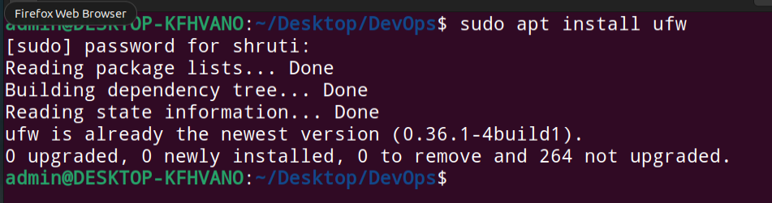

pacman:

pacman is a package manager for the arch Linux and arch-based Linux distributions.

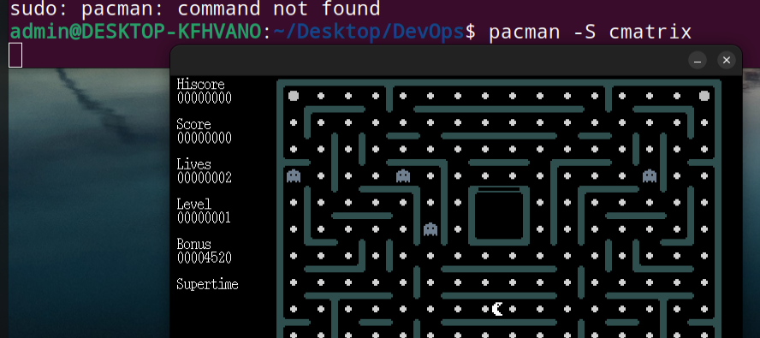

yum:

yum is the primary tool for getting, installing, deleting, querying, and managing Red Hat Enterprise Linux RPM software packages from official Red Hat software repositories, as well as other third-party repositories.

rpm:

RPM is a command-line utility for managing packages on Unix/Linux systems. It allows you to install, query, update, verify and remove RPM packages.

sudo:

The Linux sudo command stands for Super User Do. Generally, it is applied as a prefix of a few commands that superuser is allowed to execute. If we prefix the command along with other commands, it would execute that command with high privileges.

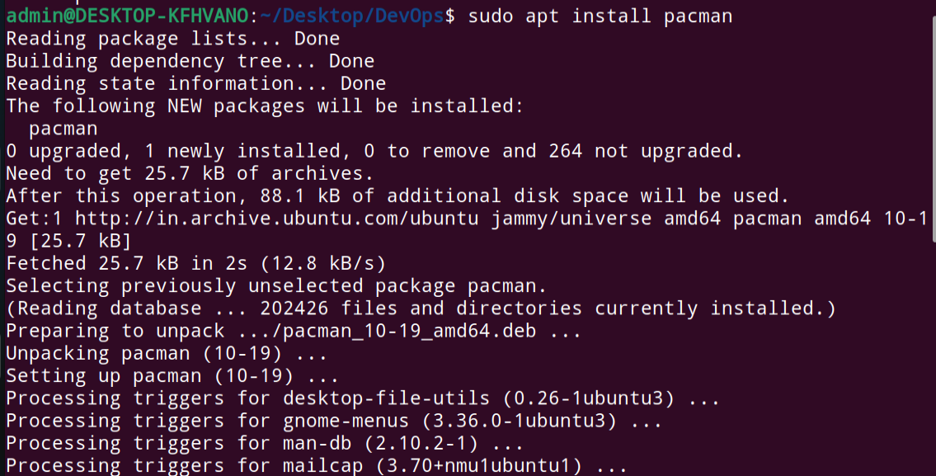

cal:

The cal command displays a calendar of the specified year or month.

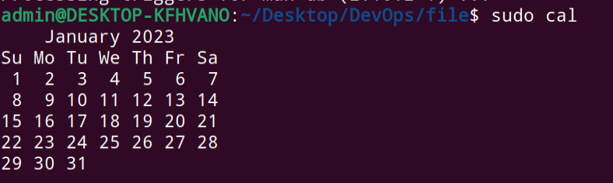

alias:

aliascommand instructs the shell to replace one string with another string while executing the commands.



dd:

dd is a command-line utility for Unix and Unix-like operating systems whose primary purpose is to convert and copy files.

whereis:

The whereis command locates the source, binary, and manuals sections for specified files.

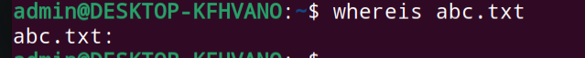

whatis:

The whatis command looks up a given command, system call, library function, or special file name, as specified by the Command parameter, from a database you create using the catman -w command. The whatis command displays the header line from the manual section.

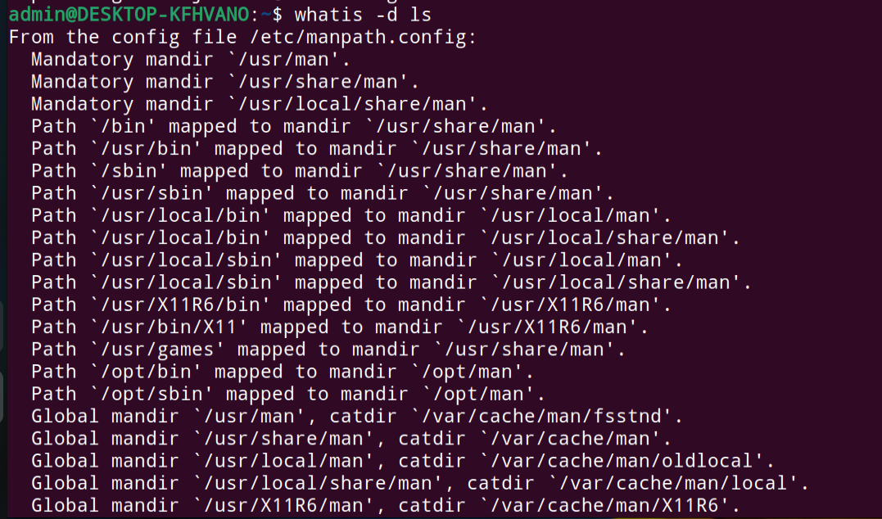

top:

top command is used to show the Linux processes. It provides a dynamic real-time view of the running system. Usually, this command shows the summary information of the system and the list of processes or threads which are currently managed by the Linux Kernel.

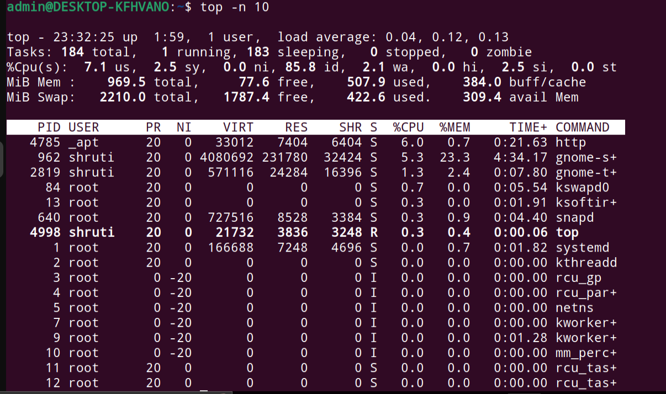

useradd:

useradd is a command in Linux that is used to add user accounts to your system. It is just a symbolic link to adduser command in Linux and the difference between both of them is that useradd is a native binary compiled with system whereas adduser is a Perl script which uses useradd binary in the background.

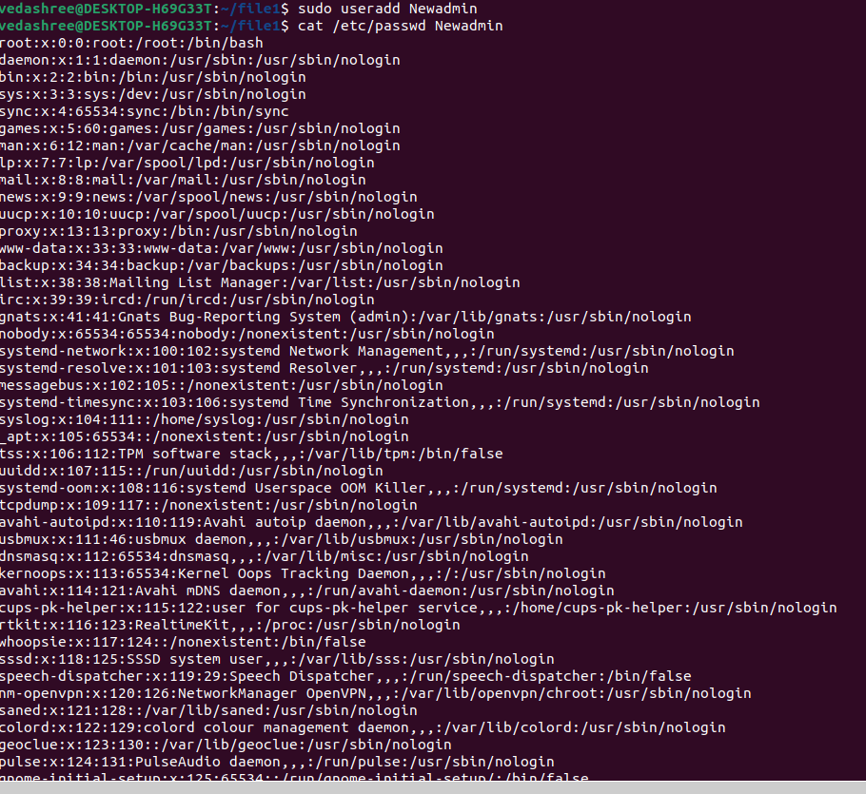



usermod:

usermod command or modify user is a command in Linux that is used to change the properties of a user in Linux through the command line. After creating a user we have to sometimes change their attributes like password or login directory etc. so in order to do that we use the Usermod command.

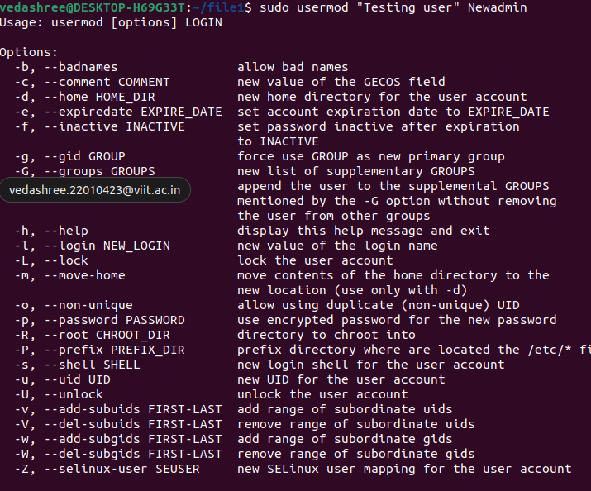

passwd:

The passwd command changes passwords for user accounts. A normal user may only change the password for their own account, while the superuser may change the password for any account.

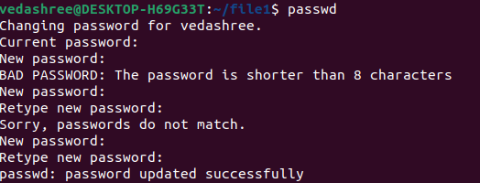

ls -1 | wc -l :

In sum, the wc command counts words and provides you with a summary of what is found. Unix will report to you how many words are in a particular file.

kill:

kill – Kill a process by ID.

w - -:

The w command is a built-in tool that allows administrators to view information about users that are currently logged in.

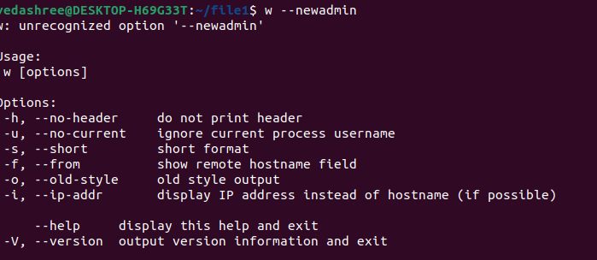

date -- :

date command is used to display the system date and time. date command is also used to set date and time of the system.



ls -a :

ls command is used to list contents of the present working directory. It can also list contents of any given path be. Path can be both absolute and relative path.



ls -l:

The ls command is one of the basic commands that any Linux user should know. It is used to list information about files and directories within the file system.

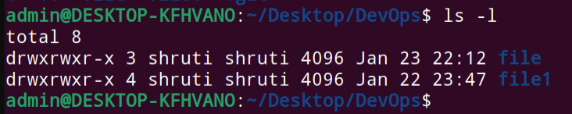

ls -R:

The ls command lists the files inside a folder.

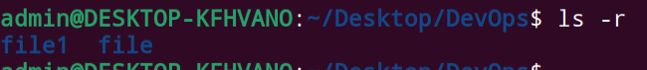

rm -rf:

rm stands for remove, and it is used to remove files, directories, and links. By default, it does not remove directories.

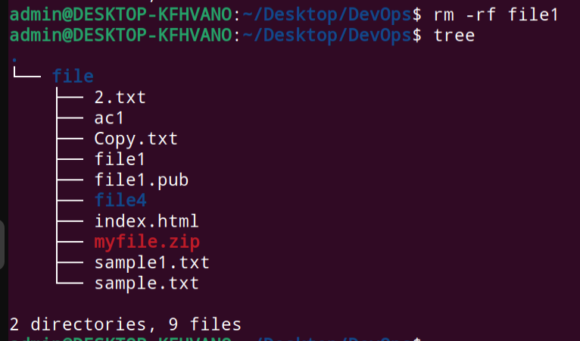

cat:

Display file contents on the terminal

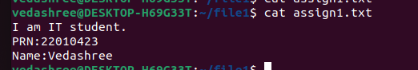

clear:

The clear command clears your screen, if possible. The clear command first checks the TERM environment variable for the terminal type.

